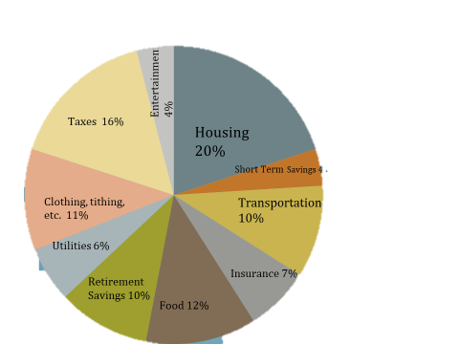
OUR FINANCIAL GOALS
IMMEDIATE CONCERN GOAL:
S:
P:
A:
M:

DURING DEPLOYMENT GOAL:

POST DEPLOYMENT GOAL:

5 YEARS FROM TODAY:

10 YEARS FROM TODAY:

ACTION STEPS FOR IMMEDIATE CONCERN:
- ______________________________________________________________
- _______________________________________________________________
- _______________________________________________________________

ACTION STEPS FOR DURING DEPLOYMENT GOAL:
- ______________________________________________________________
- _______________________________________________________________
- _______________________________________________________________

ACTION STEPS FOR POST DEPLOYMENT GOAL:
- ______________________________________________________________
- ______________________________________________________________
- ______________________________________________________________

ACTION STEPS FOR 5 YEARS GOAL:
- ______________________________________________________________
- _______________________________________________________________
- _______________________________________________________________

ACTION STEPS FOR 10 YEARS GOAL:
- ______________________________________________________________
- _______________________________________________________________
- _______________________________________________________________

